Global Student Migration
Subash Karthick Suriyamurthy
Bellevue University

Introduction
International student migration plays an increasingly vital role in global education systems, national economies, and workforce development. Countries such as the United States, the United Kingdom, Canada, and Australia attract millions of students each year. This influx is driven by factors like academic quality, career opportunities, financial support, and favorable post-study work policies.
Understanding and anticipating student migration patterns is essential for universities, policymakers, and private organizations that rely on accurate enrollment predictions, budget planning, recruitment strategies, and immigration policy development.
This project utilizes predictive analytics techniques to analyze the Global Student Migration dataset, aiming to identify patterns, determine key factors influencing migration flows, and build models for forecasting future student movements. The analysis focuses on academic variables, financial incentives, and country-level characteristics that impact the number of students migrating from their home countries to a chosen destination in a given year. Furthermore, by comparing models trained on data up to 2019 with those trained on data through 2020, this project evaluates how global disruptions—such as the COVID-19 pandemic—affect the accuracy and stability of forecasting models.
The description also includes a discussion on policy implications, including immigration reforms, post-study work rights, and the balance between national interests and global talent acquisition. Issues like brain drain in developing countries versus brain gain in destination countries are examined to understand the socio-economic impact of student migration.

Overview of Data Used:
The dataset used in this project is a student-level collection that contains over 5,000 observations and 20 variables. Each row represents an individual student and includes various details such as the student's country of origin, destination country, year of enrollment, academic performance indicators, test scores, placement outcomes, and scholarship status.
Key Variables Included in Modeling
- origin_country – Student’s home country
- destination_country – Country they migrated to
- year_of_enrollment – Year the student started
- student_count (aggregated) – Number of students from each origin to each destination per year
- avg_gpa – Average GPA for students in that country-year group
- avg_test_score – Average standardized test score
- scholarship_rate – Proportion receiving scholarships
- placement_rate – Proportion placed in jobs post-graduation
Data Exploration:
- df.head() - Displays the first five rows of the dataset, providing a quick overview of the data structure and sample values for each column, including student origins, destinations, universities, courses, and placement details.
- df.info() - Summarizes the DataFrame concisely, including entry counts, column names, data types, and non-null value counts. This helps identify missing data and understand the overall schema.
- df.shape() - The dataset consists of 5,000 rows and 20 columns, indicating its size and complexity.
- df.nunique() - High cardinality is expected for student_id, with approximately 5,000 unique IDs anticipated. There will be dozens of levels for countries, cities, universities, and courses, along with a few levels for status, visa, and scholarship fields
Data Preparation:
- Duplicate rows were removed to ensure that no student was counted more than once.
- Missing values in placement-related fields were replaced with "Unknown" to maintain data completeness.
- The data was aggregated at the country, destination, and year level to create a structured dataset suitable for forecasting.
- Categorical fields, such as countries, were label-encoded.
- Features were scaled using MinMax normalization.
- Two forecasting windows were tested:
  - Model Set A: Training ≤ 2019, Testing > 2019
  - Model Set B: Training ≤ 2020, Testing > 2020
This structure enabled the project to analyze migration trends over time and simulate real-world forecasting scenarios.

Data Visualization:
- Top 10 Destination Countries:
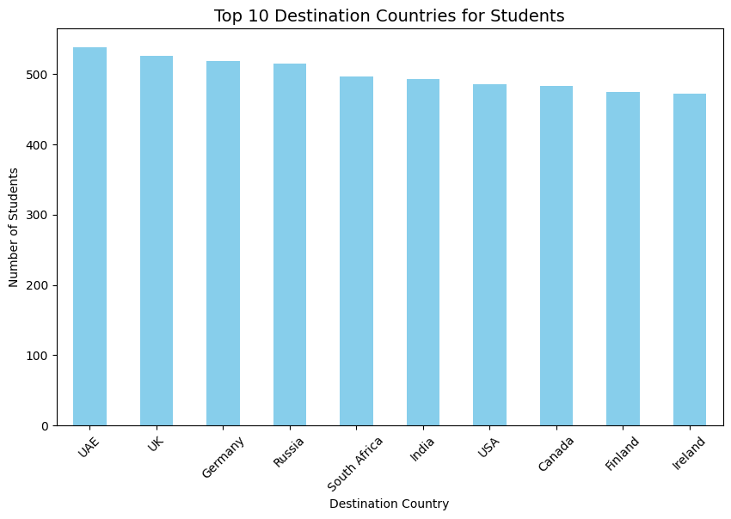
- The UAE is the leading destination for students, with just over 540 individuals choosing to study there, highlighting its strong appeal compared to other countries.
- Following closely behind are the UK and Germany, both of which have student numbers exceeding 520, indicating that Europe continues to be a popular choice for student migration.
- On the other hand, Ireland and Finland rank at the bottom of the top 10 destinations, each attracting just under 480 students, suggesting they are relatively less attractive compared to the UAE and the UK.

- Scholarship Distribution by Destination Country
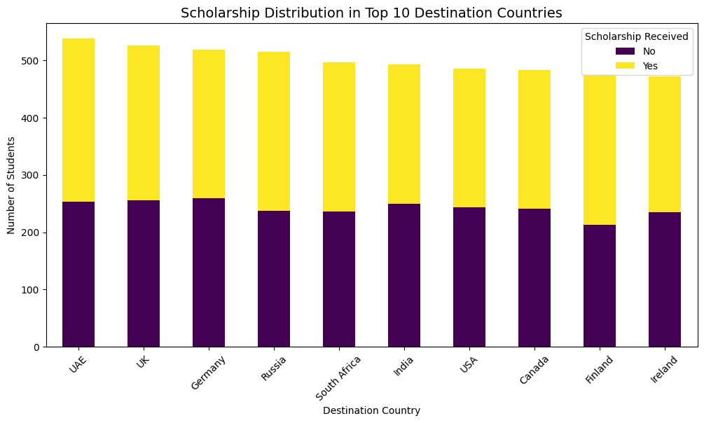
- In all the top 10 destination countries, the yellow bars (representing students who received scholarships) are larger than the purple bars (representing those without scholarships). This indicates that the majority of students benefit from scholarships.
- The UAE, UK, and Germany lead in the number of scholarships offered. These countries not only have the highest total student populations but also the largest segments of scholarship recipients, suggesting a strong availability of financial aid or an appeal for students seeking scholarships.
- In contrast, Finland and Ireland exhibit relatively lower proportions of scholarships. Although these countries have fewer total students, the gap between scholarship recipients and non-recipients is narrower, indicating that there are fewer scholarships available compared to leading destinations like the UAE and UK.

- Placement Status by Field of Study
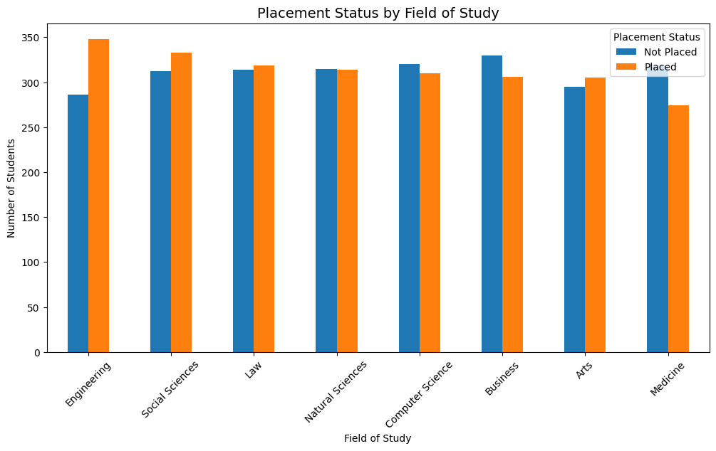
- Engineering demonstrates the largest gap favoring 'Placed' students, indicating strong employability in this field.
- In contrast, the 'Not Placed' categories for Medicine and Arts are taller than the 'Placed' bars, suggesting that these areas encounter more challenges in job placement compared to technical or business disciplines.
- Furthermore, both Medicine and Arts show nearly equal numbers of placed and not placed students, reflecting moderate placement success without a clear advantage for either group.

- Average Starting Salary by Destination Country
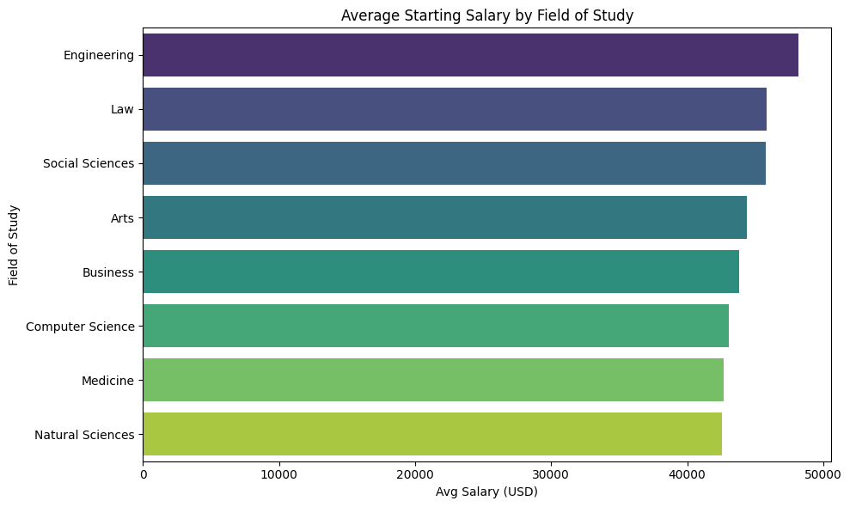
- Engineering graduates earn the highest average salary, approximately $48,000, which is significantly more than graduates from other fields.
- Both technical and non-technical disciplines have strong earning potential, with average salaries around $45,000, indicating competitive compensation for non-technical professions.
- On the other hand, fields with the lowest average starting salaries range from $42,000 to $43,000, suggesting limited initial earning opportunities compared to technical and legal fields.

Methods of Analysis:
Three predictive modeling techniques were employed to forecast the annual migration counts:
1. Ridge Regression (Linear Model)
Selected for its interpretability and as a baseline for comparison with more complex methods, Ridge regression can identify linear relationships between features and migration volume; however, it fails to capture nonlinear patterns.
2. Random Forest Regressor
A tree-based ensemble model that effectively captures complex, nonlinear interactions. Random Forest handles categorical encodings well and generally exhibits reliable generalization.
3. XGBoost Regressor
XGBoost is a gradient boosting method known for its strong performance on structured datasets, providing additional insights through feature importance scores.
Evaluation Metrics
Models were evaluated using:
- Mean Absolute Error (MAE)
- Root Mean Squared Error (RMSE)
- Mean Absolute Percentage Error (MAPE)
Instead of using random splitting, the project employed chronological splitting. It trained on data from 2019 and 2020 while testing on subsequent years. This approach reflects real-world forecasting, where future data is unknown at the time of training. It also provided an opportunity to examine how global shocks, such as the COVID-19 pandemic, influence model performance. This methodology ensured that the evaluation metrics corresponded to practical forecasting performance.

To assess the stability of the XGBoost model, we applied 5-fold cross-validation to the fully scaled dataset. This procedure confirmed whether the model generalizes well across different subsets and helps avoid overfitting. The use of multiple metrics and cross-validation strengthened the reliability of the model comparisons.
Results and Findings:
Model with till 2019 train data | MAE | RMSE | MAPE
Ridge Regression | 2.65 | 3.37 | 30.08%
Random Forest | 2.61 | 3.32 | 29.72%
XGBoost | 2.68 | 3.39 | 29.75%
Model till 2020 train data
Ridge Regression | 2.60 | 3.27 | 27.09%
Random Forest | 2.53 | 3.21 | 27.22%
XGBoost | 2.70 | 3.40 | 27.68%

Model Results Interpretation (Train ≤ 2019, Test ≥ 2020):
Training on data up to 2019 allowed the models to capture a period of steady global student growth. Evaluation from 2020–2023 showed slightly increased prediction errors due to the pandemic. However, all models maintained a MAPE around 30%, indicating that their learned relationships remained largely valid.
Model Performance:
- Random Forest: Best overall performance (MAE = 2.61, RMSE = 3.32, MAPE ≈ 29.7%), balancing bias and variance well.
- XGBoost: Similar accuracy (MAE = 2.68), robust for non-linear relationships but could benefit from further tuning.
- Ridge Regression: Lagged due to its focus on linear associations, missing complex interactions.
The consistent performance hierarchy affirms the stability of economic and academic predictors over time.
Feature Importance Insights (XGBoost):
- Top predictors included Scholarship Rate and Placement Rate, underscoring financial support and career prospects as key motivators for student migration.
- Academic indicators, like test scores and GPA, were also significant, while country-level factors contributed less, indicating that individual and institutional factors are more influential.
Trend Interpretation:
- Models tracked the steady upward trend in migration until 2019 but underestimated volatility after 2020 due to pandemic shocks.
- This highlights the challenge of relying on historically stable data amid abrupt global changes. Nonetheless, core relationships—such as financial support, academic strength, and career opportunities—remained relevant.
Implications and Learnings:
- Pre-2020 models show that migration flows are predictable under stable conditions but sensitive to external shocks.
- Future models should incorporate policy variables (visa rules, travel restrictions) and economic indicators (GDP growth, inflation) to better adapt to unforeseen events.

Model Results Interpretation (Train ≤ 2020, Test > 2020):
Updated the model's train/test split (training data until 2020 and testing data afterward); results and feature importance plots indicate only minor refinements in interpretation.
Model Performance:
- The Random Forest model outperformed all others, achieving the lowest Mean Absolute Error (MAE) of 2.53 and Root Mean Square Error (RMSE) of 3.21.
- XGBoost closely followed, with an MAE of 2.60 and an RMSE of 3.27, demonstrating consistent performance in generalization.
- Ridge Regression, while not as accurate, still served as a valuable linear baseline and confirmed that the fundamental relationships between features and migration remain stable.
Overall error rates, with a Mean Absolute Percentage Error (MAPE) of approximately 27%, are considered reasonable given the variability caused by global factors such as post-pandemic fluctuations.
Feature Importance:
Top Predictors (XGBoost):
- Scholarship Rate: This is the strongest predictor; financial aid plays a significant role in driving migration.
- Placement Rate: Career prospects greatly influence individuals' choices regarding where to study.
- Average Test Score and GPA: Academic readiness is an important factor in determining destination selection.
- Destination and Origin Country: These have a moderate impact, reflecting the attractiveness of the destination and regional availability.
- Year of Enrollment: While this factor is the least influential, it does capture the overall growth trend in migration patterns.
Trend Implications:
- Incorporating data from 2020 into the training has enhanced adaptability, making it easier to predict recovery patterns following the pandemic.
- Migration volumes have stabilized, as the decline observed from 2020 to 2021 is now considered part of the established trend.
- The primary factors driving migration, such as scholarships and placements, continue to be the most influential, while temporal and regional effects are secondary but consistently relevant.
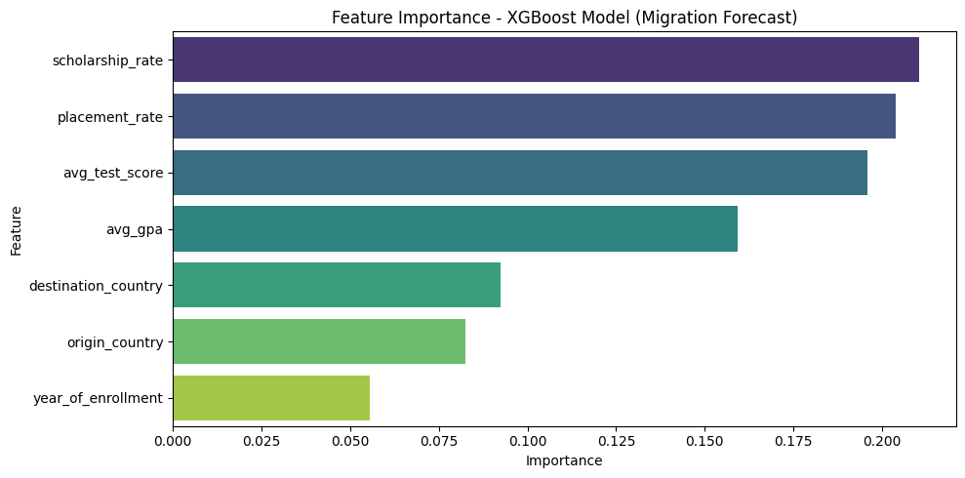

Conclusions:
The predictive models developed for this project offer valuable insights into the factors influencing international student migration. Tree-based models, specifically Random Forest and XGBoost, consistently outperformed Ridge Regression. This suggests that migration is affected by nonlinear interactions among academic, financial, and country-level factors.
Comparing the models based on data from 2019 and 2020 showed that incorporating pandemic-era data improved both accuracy and robustness. This highlights the importance of considering both stable and volatile periods to create effective migration forecasts.
The feature importance analysis reveals that scholarship availability and post-study placement opportunities are the most significant predictors of student movement. Academic metrics are also important, while trends over time played a surprisingly minor role.
Recommendations:
For Policymakers and Governments:
- Enhance Scholarship Initiatives: Increase both need-based and merit-based financial aid to attract more international students.
- Support Employment After Graduation: Streamline the process of transitioning from student visas to work permits to retain graduates from abroad.
- Invest in Academic Collaborations: Create bilateral agreements to broaden the diversity of source regions and ensure stable student mobility.
For Universities and Institutions:
- Target High-Potential Regions: Recruit from countries showing increasing scholarship and test-score trends.
- Monitor Placement Outcomes: Strong job placements enhance institutional appeal and drive migration.
- Leverage Data Forecasting: Use predictive analytics to adjust housing, staffing, and programs based on student inflow.
Q&A from Milestone2:
1. How can universities, policymakers, or governments actually use these migration forecasts for decision-making?
Universities can utilize forecasts to plan for enrollment capacity, housing, faculty hiring, and scholarship budgets by anticipating the number of students coming from specific countries. Policymakers and governments can use these forecasts to evaluate the effectiveness of financial aid programs, post-study work policies, and talent retention strategies. The model highlights scholarship and placement rates as key factors, allowing decision-makers to simulate how increasing funding or enhancing employability outcomes might influence future student enrollment.

2. How might the results differ if another major destination (e.g., Canada, UK, Australia) were used as the focal point?
The relative importance of various factors may change over time. For instance, post-study work rights and immigration pathways might become more significant predictors for choosing Canada or Australia, while tuition costs and visa restrictions could be more critical for the UK. Nevertheless, the paper indicates that institutional-level factors, such as scholarships and job placements, tend to be more influential than macroeconomic indicators. This suggests that these factors will continue to be important across different destinations, even if their relative significance changes.

3. Can the model adapt to future shocks that are not present in historical data?
The findings indicate that models trained only until 2019 underestimated market volatility during the COVID-19 pandemic. In contrast, models trained through 2020 adapted more effectively, although they still relied on historical patterns. While tree-based models are capable of capturing nonlinear relationships, truly unprecedented events—such as pandemics, wars, or sudden visa bans—require the inclusion of specific policy or shock variables to enhance their adaptability.

4. What characteristics of the dataset made Random Forest more effective?
The dataset contains nonlinear relationships, a mix of feature types, and interactions among academic, financial, and country-level variables. The Random Forest algorithm effectively addressed these complexities without assuming linearity. It also managed label-encoded categorical features well and minimized overfitting through ensemble averaging. As a result, Random Forest consistently achieved lower Mean Absolute Error (MAE) and Root Mean Square Error (RMSE) compared to Ridge Regression.

5. Why do scholarship rate and placement rate appear more important than country-level economic indicators?
Scholarship and placement rates have a direct impact on a student’s affordability and potential career return on investment, which are crucial factors in decision-making. Country-level indicators tend to be more indirect and are often quite similar across popular destinations. The paper’s feature importance analysis confirms that individual and institutional incentives are more influential than the broader economic context when it comes to migration decisions.

6. Are smaller or less-reported countries disadvantaged in the model’s predictions?
Yes, to some extent. Countries with fewer data points contribute less information during training, which can lead to greater uncertainty in predictions. Aggregating data at the country-destination-year level helps alleviate this issue, but forecasts for smaller countries should be interpreted with a greater degree of uncertainty compared to those for larger, high-volume origin countries.

7. What are the advantages of MAPE when comparing countries with very different student volumes?
MAPE (Mean Absolute Percentage Error) normalizes errors based on actual student counts, enabling fair comparisons between countries with high student volumes and those with low student volumes. This is especially important in migration forecasting, where errors of similar magnitude can have significantly different implications depending on the scale of the population. The paper utilizes MAPE to demonstrate reasonable accuracy, even when dealing with varying student volumes.

8. How can such models be misused in immigration or education policy decisions?
These models can be misused if they are viewed as deterministic forecasts instead of probabilistic estimates. Relying too heavily on these predictions might lead to restrictive visa policies, limit access for smaller countries, or prioritize revenue over fairness. The paper highlights that forecasts should support, rather than replace, human judgment and ethical considerations in policy-making.

9. Would visa policy indicators or macroeconomic shocks significantly reduce forecast error?
The paper clearly states that including factors such as visa regulations, travel restrictions, GDP growth, and inflation could enhance performance during times of volatility. These variables would enable models to respond to structural changes, like those caused by COVID-19, instead of relying solely on stable historical trends.

10. What should decision-makers not assume based on these predictions?
Decision-makers should not take for granted that conditions will remain stable during crises, nor should they assume that there are consistent causal relationships between predictors and outcomes, or that accuracy will be uniform across all countries. The predictions presented reflect historical correlations, rather than guarantees. The paper warns that forecasts are most useful as directional guidance in times of uncertainty, particularly during global disruptions.

References:
- Kaggle. (2024). Global Student Migration Dataset. https://www.kaggle.com
- XGBoost Developers. (2023). XGBoost Documentation. https://xgboost.readthedocs.io
- Pedregosa, F., et al. (2011). Scikit-learn: Machine learning in Python. Journal of Machine Learning Research, 12, 2825–2830.

